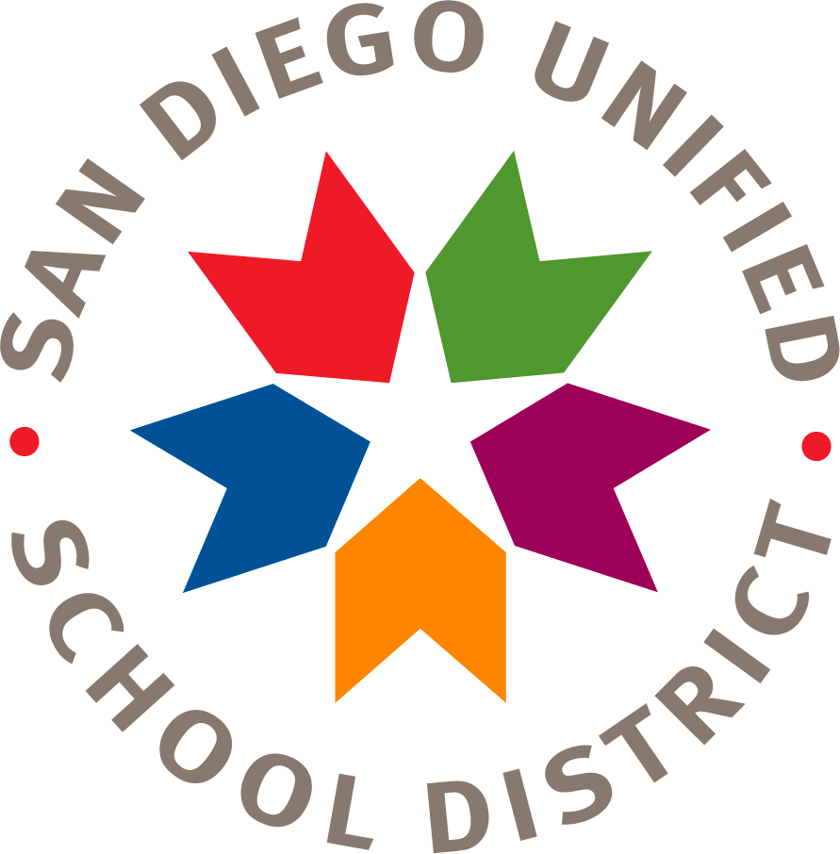
San Diego Unified School District
Finance Division
Strategic Planning for Student Achievement Department

Annual Requirements for Title I Schools Verification Form 2021-22

School Name

- The Annual Title I Parent Meeting was held on:

- The site Title I Parent & Family Engagement Policy
was approved by the SSC on (document in SSC minutes):

- The site Title I Parent & Family Engagement Policy
was distributed to parents on:

- The site School Parent Compact
was approved by the SSC on (document in SSC minutes):

- The site School Parent Compact
was distributed to parents by (describe how):

- The district Title I Parent and Family Engagement Policy
was distributed to parents on:

- The Uniform Complaint Procedures (UCP) Annual
Notice was distributed to SSC members at the first
SSC meeting of the year on: __________________

The undersigned declares under penalty that the foregoing is true and correct.

PRINT Principal’s Name Principal’s Signature

Retain a copy of this document in your SSC (School Site Council) binder
for state and federal auditing purposes.
Send ORIGINAL document to:

EDUCATION CENTER, Room 3126
Strategic Planning for Student Achievement Department
4100 Normal Street, San Diego CA 92103
Due by October 29, 2021

